ShopEZ — E-commerce Application

1. Introduction
- Project Title: ShopEZ — A MERN Stack E-commerce Application
- Team Members: This is a solo project.
  - Developer: [Vishal Gudla] — Full Stack Development (Frontend, Backend, Database Design, Deployment)

2. Project Overview

Purpose
ShopEZ is a full-stack e-commerce platform designed to provide a seamless online shopping experience tailored for Indian customers. The goal of the project is to build a production-style application that demonstrates a complete shopping flow — from product discovery and cart management to secure checkout and order tracking — alongside a comprehensive admin panel for managing products, orders, and users. The application follows the Model-View-Controller (MVC) architectural pattern to ensure clean separation of concerns, scalability, and maintainability.

Features
- Product Catalog: Browse, search, and filter products by category, with detailed product pages showing descriptions, pricing in ₹, and stock availability.
- User Authentication & Roles: Secure registration and login using JWT, with role-based access for regular users and admins.
- Persistent Cart: Cart items are stored in MongoDB so they persist across devices and sessions.
- Indian Localization: Prices displayed in ₹ with Indian number formatting (en-IN), free shipping above ₹500, flat ₹50 fee below that, and validation for 10-digit Indian mobile numbers and 6-digit pincodes.
- Secure, Transaction-Safe Checkout: Stock validation, order creation, stock decrement, and cart clearing happen as a single safe operation. Orders use Cash on Delivery (COD).
- Order Tracking: Users can view their order history and current status from their profile.
- Admin Dashboard: Metrics for total users, products, orders, and revenue, plus the 5 most recent orders, full product CRUD, order status management, and user listing.
- Custom Branding: A custom logo combining a shopping bag outline with a stylized ₹ symbol, using an Indian tricolor (saffron-white-emerald) accent and gold-to-emerald gradient text.

3. Architecture

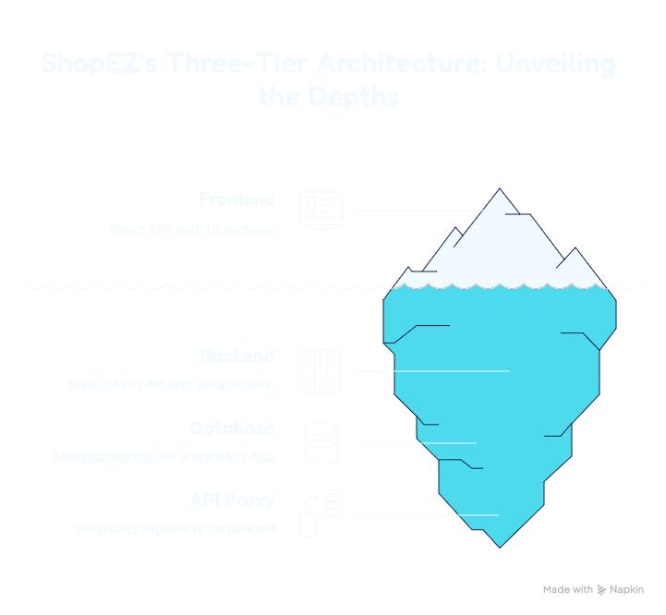

Frontend
The frontend is a React 18 (TypeScript) Single Page Application built with Vite for fast development and Hot Module Replacement. Styling is handled with TailwindCSS for a utility-first, responsive design, and Lucide React provides consistent UI icons. Routing is managed using React Router DOM (v7), and React Hot Toast handles non-blocking user notifications.
State management relies on React Context: AuthContext.tsx manages customer and admin authentication state, while CartContext.tsx manages cart contents and price calculations. All communication with the backend goes through a unified API service wrapper (lib/api.ts), and shared TypeScript interfaces are defined in types/index.ts. Pages cover the full customer journey (Home, Products, Product Detail, Cart, Checkout, Login, Register, Profile, Orders) as well as the admin section (Dashboard, Products, Orders, Users).

Backend
The backend is a Node.js application using Express.js to expose a RESTful API, structured according to the MVC pattern:
- Models: Mongoose schemas defining the data layer — User, Product, Category, CartItem, Order, and Admin.
- Controllers: Business logic for each resource — authController, productController, categoryController, cartController, orderController, and adminController.
- Routes (View Layer): Endpoint definitions mapping HTTP methods to controller functions — authRoutes, productRoutes, categoryRoutes, cartRoutes, orderRoutes, and adminRoutes.
- Middleware: auth.js provides protect (JWT verification) and adminOnly (role-based access) guards; errorHandler.js is the global exception handler.
Authentication uses JWT for stateless sessions and bcryptjs for password hashing. Additional middleware includes body-parser, CORS, cookie-parser, and dotenv for environment configuration. The server runs on http://localhost:8000.

Database
ShopEZ uses MongoDB as its database, accessed through Mongoose ODM. The schema is organized around six core collections:
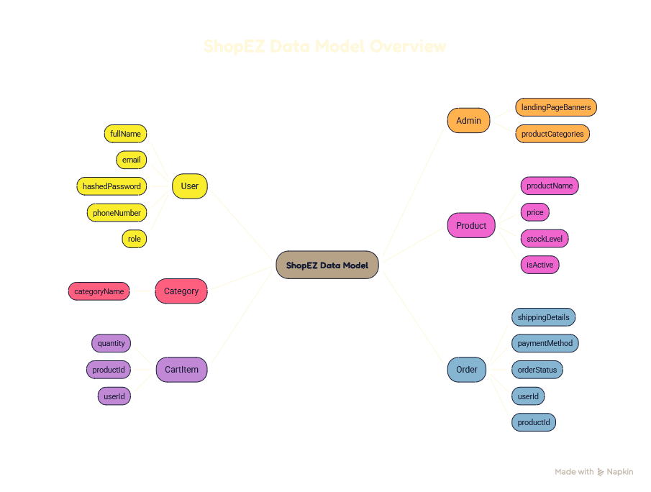
Collection | Description
User | Stores fullName, email (unique), hashed password, phone, and role ('user' or 'admin').
Product | Stores product name, description, price (₹), category, stock level, image, and active status.
Category | Stores the list of product categories used to organize and filter the catalog.
CartItem | Stores userId, productId, and quantity — representing items in a user's persistent cart.
Order | Stores userId, ordered items, shipping address, phone, pincode, payment method (COD), shipping fee, total amount, status, and order date.
Admin | Stores administrative configuration such as landing page banners and categories.
Relationships are maintained via references: CartItem and Order documents reference the User who owns them, and Order items reference Product documents. Placing an order is handled as a transaction-safe sequence — validating stock, creating the order, decrementing product stock, and clearing the cart.

4. Setup Instructions

Prerequisites
- Node.js (v18 or above) — runtime for both client and server.
- npm (v8 or above) — package manager for installing dependencies.
- MongoDB — local instance (e.g., via MongoDB Compass) or a cloud instance (MongoDB Atlas).
- Git — for cloning the repository.
- Postman (optional) — for testing API endpoints.
- Code Editor — Visual Studio Code recommended.

Installation
- Clone the repository:
git clone <repository-url>
cd ShopEz-main
- Install backend dependencies:
cd server
npm install
- Configure backend environment variables: Create a .env file inside the server folder with the following:
MONGO_URI=mongodb://localhost:27017/shopez
JWT_SECRET=<your-secret-key>
PORT=8000
- Seed the database with sample INR products and admin accounts:
npm run seed
- Install frontend dependencies:
cd ../client
npm install
- Start the application (see Section 6 for running both servers).

5. Folder Structure

Client (React Frontend)
The client folder contains the Vite + React + TypeScript application:
- src/components/ — Reusable UI components, split into common/ (Logo, Spinners, Skeletons), layout/ (MainLayout, Navbar, Sidebar), and products/ (ProductCard, ProductGrid).
- src/context/ — React Context providers: AuthContext.tsx (authentication state) and CartContext.tsx (cart management and calculations).
- src/lib/api.ts — Unified REST API service wrapper used by all pages to communicate with the backend.
- src/pages/ — Page-level components: HomePage, ProductsPage, ProductDetailPage, CartPage, CheckoutPage, LoginPage, RegisterPage, ProfilePage, OrdersPage, and an admin/ subfolder containing AdminLayout, AdminDashboard, AdminProducts, AdminOrders, and AdminUsers.
- src/types/index.ts — Shared TypeScript interface declarations.
- src/App.tsx — Root router and context provider setup.
- src/main.tsx — Application entry point.
- src/index.css — Global styles and Tailwind imports.
- vite.config.ts — Vite configuration, including the proxy of /api requests to http://localhost:8000.

Server (Node.js Backend)
The server folder contains the Express + MongoDB backend, organized using the MVC pattern:
- models/ — Mongoose schemas: Admin.js, CartItem.js, Category.js, Order.js, Product.js, User.js.
- controllers/ — Business logic: adminController.js, authController.js, cartController.js, categoryController.js, orderController.js, productController.js.
- routes/ — API endpoint definitions: adminRoutes.js, authRoutes.js, cartRoutes.js, categoryRoutes.js, orderRoutes.js, productRoutes.js.
- middleware/ — auth.js (protect & adminOnly guards) and errorHandler.js (global exception handler).
- server.js — Application entry point; starts the server and connects to MongoDB.
- seed.js — Seeds the database with sample INR products and admin accounts.
- .env — Local environment configuration (MongoDB URI, JWT secret, port).

6. Running the Application
The client and server are run independently, in separate terminals.

Backend
- Navigate to the server directory and start the backend:
cd server
npm run dev
The backend server starts on http://localhost:8000 (using nodemon for auto-restart on changes).

Frontend
- Navigate to the client directory and start the frontend:
cd client
npm run dev
The frontend dev server starts on http://localhost:5173. Any request made to /api from the frontend is automatically proxied to http://localhost:8000, avoiding CORS issues.

7. API Documentation
All endpoints are prefixed with /api. Protected routes require an Authorization: Bearer <token> header; admin-only routes additionally require the user's role to be 'admin'

Authentication — /api/auth
Method | Endpoint | Description | Auth
POST | /api/auth/register | Register a new user (fullName, email, password, phone) | Public
POST | /api/auth/login | Authenticate user and return a JWT | Public
GET | /api/auth/profile | Get the logged-in user's profile | Protected
PUT | /api/auth/profile | Update the logged-in user's profile | Protected

Products — /api/products
Method | Endpoint | Description | Auth
GET | /api/products | Get a list of all products (supports filtering/search) | Public
GET | /api/products/:id | Get details of a single product | Public
POST | /api/products | Add a new product | Admin
PUT | /api/products/:id | Update an existing product | Admin
DELETE | /api/products/:id | Delete a product | Admin
PATCH | /api/products/:id/status | Toggle a product's active status | Admin

Categories — /api/categories
Method | Endpoint | Description | Auth
GET | /api/categories | Get a list of all product categories | Public
POST | /api/categories | Add a new category | Admin
PUT | /api/categories/:id | Update a category | Admin
DELETE | /api/categories/:id | Delete a category | Admin

Cart — /api/cart
Method | Endpoint | Description | Auth
GET | /api/cart | Get the current user's cart items | Protected
POST | /api/cart | Add an item to the cart | Protected
PUT | /api/cart/:id | Update the quantity of a cart item | Protected
DELETE | /api/cart/:id | Remove an item from the cart | Protected
DELETE | /api/cart | Clear the entire cart | Protected

Orders — /api/orders
Method | Endpoint | Description | Auth
POST | /api/orders | Place a new order (validates stock, decrements stock, clears cart) | Protected
GET | /api/orders | Get the current user's order history | Protected
GET | /api/orders/:id | Get details of a specific order | Protected

Admin — /api/admin
Method | Endpoint | Description | Auth
GET | /api/admin/dashboard | Get dashboard metrics (totals for users, products, orders, revenue, recent orders) | Admin
GET | /api/admin/orders | Get a list of all orders | Admin
PUT | /api/admin/orders/:id/status | Update an order's status (pending → confirmed → packed → shipped → delivered → cancelled) | Admin
GET | /api/admin/users | Get a list of all registered users | Admin

Example Request & Response
Example: placing an order via POST /api/orders
Request Body:
{
"items": [{ "productId": "64f1a2...", "quantity": 2 }],
"shippingAddress": "123 MG Road, Hyderabad",
"phone": "9876543210",
"pincode": "500081",
"paymentMethod": "COD"
}
Response (201 Created):
{
"orderId": "64f2b3...",
"status": "pending",
"totalAmount": 950,
"shippingFee": 0,
"message": "Order placed successfully"
}

8. Authentication
ShopEZ uses JSON Web Tokens (JWT) for stateless authentication and authorization:
- Registration: Users register with fullName, email, password, and phone number. Passwords are hashed using bcryptjs before being stored in MongoDB, so plaintext passwords are never persisted.
- Login: On successful login, the server signs a JWT (using JWT_SECRET) and returns it to the client.
- Token Storage & Usage: The frontend stores the JWT in the browser's localStorage and attaches it as a Bearer token (Authorization: Bearer <token>) in subsequent API requests.
- Protected Routes: The protect middleware verifies the JWT on incoming requests and attaches the authenticated user to the request object. Requests without a valid token are rejected with a 401 Unauthorized response.
- Role-Based Authorization: Users have a role field ('user' or 'admin'). The adminOnly middleware checks this role and restricts access to admin-only routes (product management, order management, user listing, dashboard metrics) to users with role: 'admin'. Non-admin users receive a 403 Forbidden response.
- Frontend Route Protection: AuthContext.tsx tracks the logged-in user's state across the app, and protected frontend routes (e.g. /profile, /admin/*) redirect unauthenticated or unauthorized users to the login page.

9. User Interface
The user interface is built with React and TailwindCSS, providing a clean and responsive shopping experience. Key screens include (insert screenshots/GIFs for each):
- Home Page: Landing page showcasing featured products, banners, and branding (custom logo with Indian tricolor accents).
- Products Page: Browsable, searchable, and filterable product grid.
- Product Detail Page: Detailed view of a single product with pricing in ₹ and stock status.
- Cart Page: View and manage items in the cart, with live total calculations.
- Checkout Page: Address entry (with phone/pincode validation), shipping fee calculation, and COD payment selection.
- Login & Register Pages: User authentication forms.
- Profile & Orders Page: User details and order history with status tracking.
- Admin Dashboard: Overview of key metrics — users, products, orders, revenue, and recent activity.
- Admin Products/Orders/Users Pages: Management interfaces for CRUD operations and order status updates.

10. Testing
Testing was carried out primarily through manual and API-level testing:
- API Testing: Postman was used to test all backend endpoints — verifying request/response formats, status codes, authentication/authorization enforcement, and error handling for both valid and invalid inputs.
- Manual UI Testing: Each page and user flow (registration, login, browsing, cart, checkout, order placement, order tracking, and admin operations) was manually tested across Chrome and Firefox to verify correct behavior and responsiveness.
- Validation Testing: Form validations — such as 10-digit mobile numbers, 6-digit pincodes, required fields, and unique email constraints — were tested with both valid and invalid inputs.
- End-to-End Flow Testing: The full order lifecycle was tested to confirm that stock validation, order creation, stock decrement, and cart clearing occur correctly as a single safe operation.
Future iterations could incorporate automated testing using Jest and React Testing Library for the frontend, and Jest/Supertest for backend API integration tests.

11. Screenshots or Demo
The following pages represent the core screens of the application (insert screenshots or a demo link for each):
Landing Page — the home page of the application.
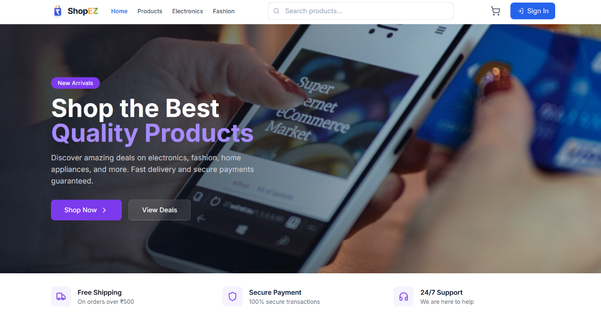

Products Page — lists all available products.

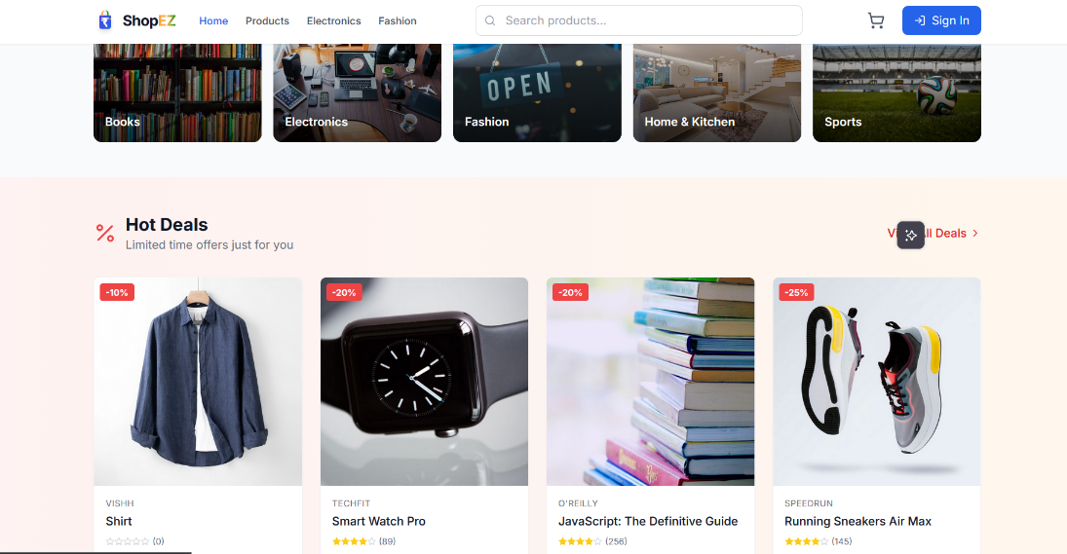

Authentication — registration and login pages.
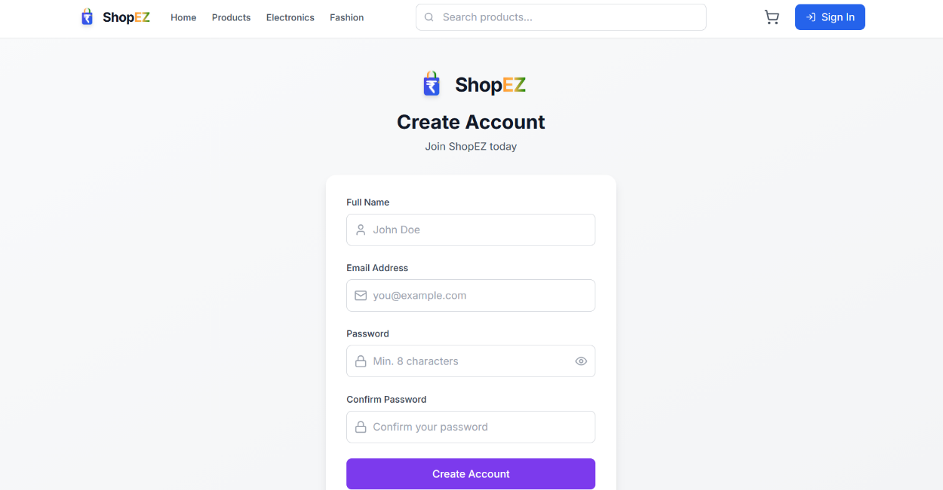

User Profile — displays user details and orders.

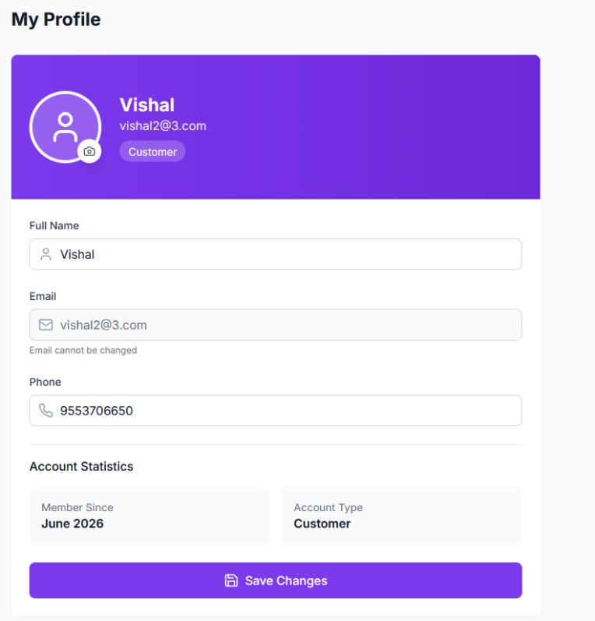

Cart Page — where users add and manage products in their cart.

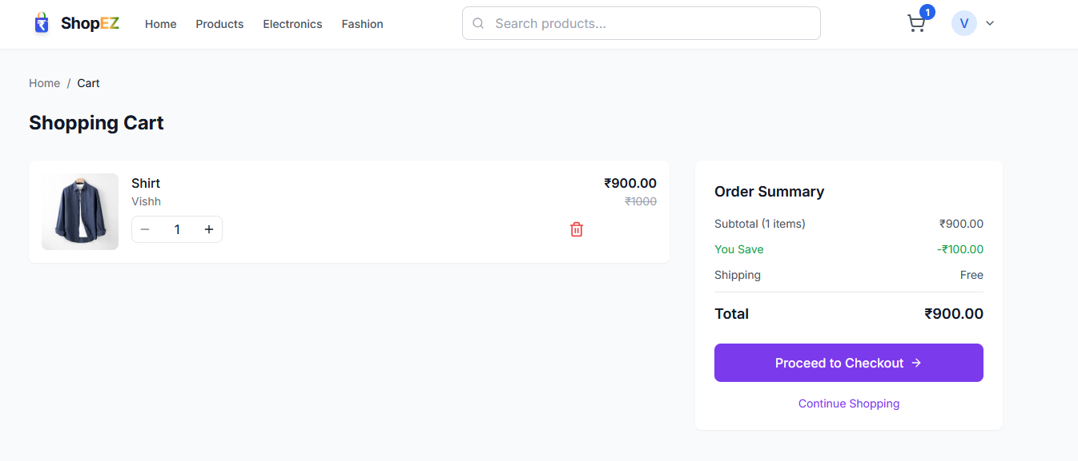
Admin Dashboard — the admin overview page.
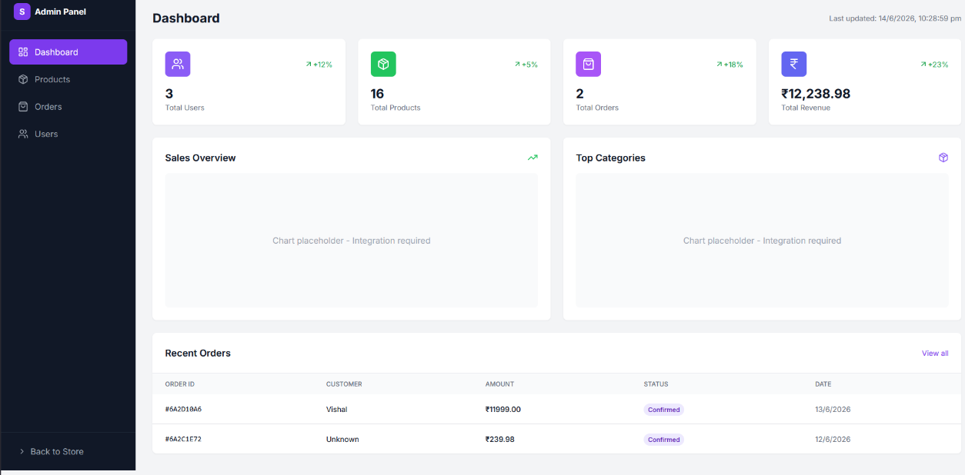
All Orders (Admin) — where admin can view and manage all orders.
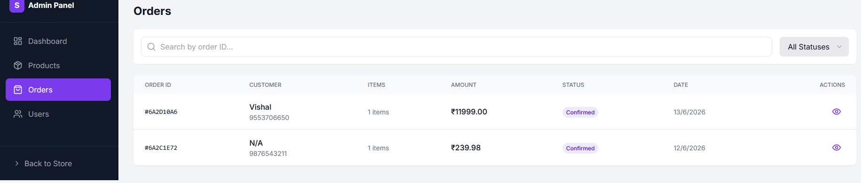

All Products (Admin) — where admin can view all available products.
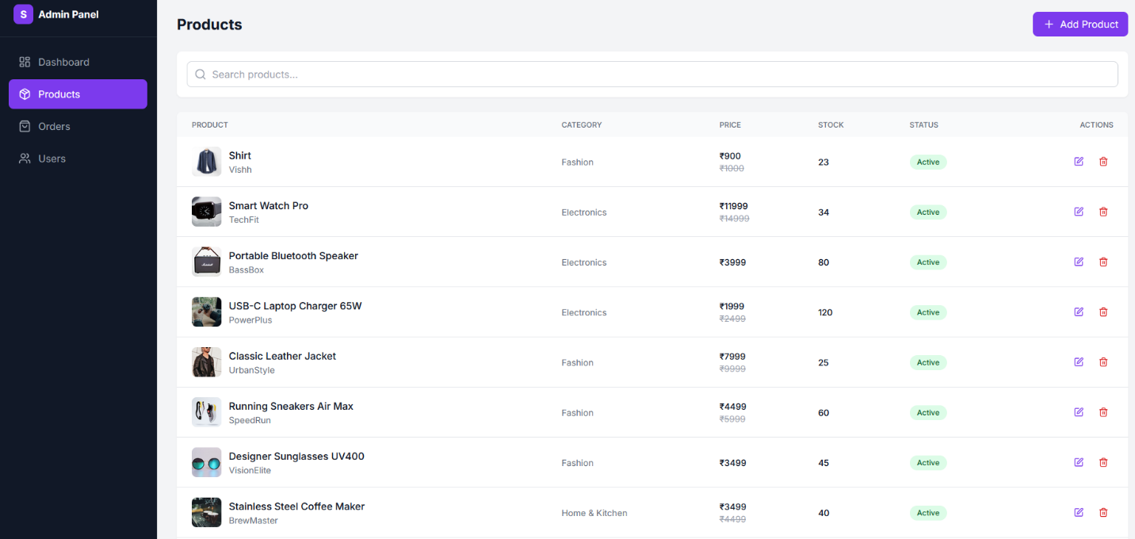
New Product Page (Admin) — where admin can add new products.
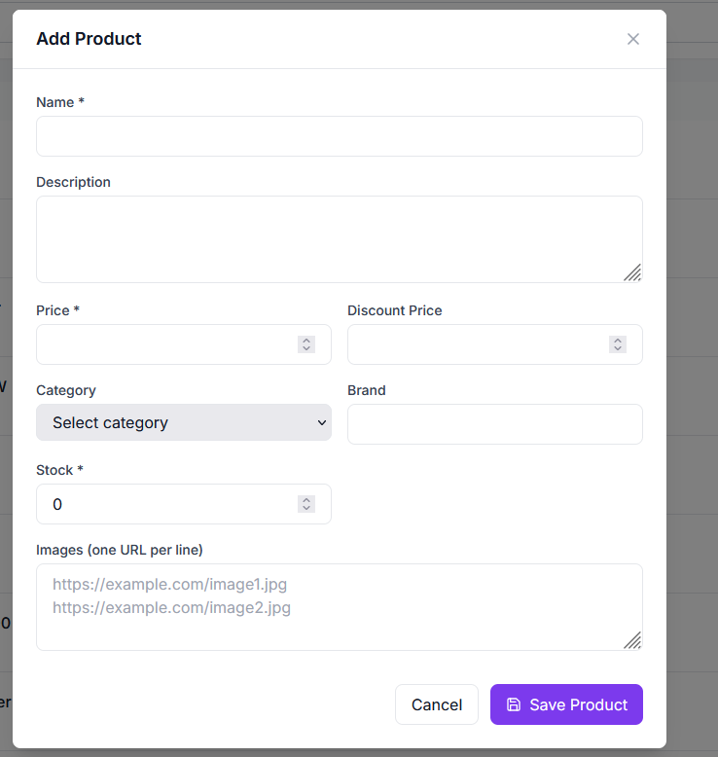
Demo Video: VIDEO LINK
Source Code: GIT HUB LINK

12. Known Issues
- Currently only Cash on Delivery (COD) is supported; no integration with online payment gateways (e.g. Razorpay, UPI) yet.
- Product image uploads are not yet integrated with a cloud storage service (e.g. Cloudinary, S3); images are referenced by URL or stored locally.
- Order status updates by admins do not yet trigger email or SMS notifications to users.
- [Add any additional known bugs or limitations discovered during development]

13. Future Enhancements
- Online Payment Integration: Add support for UPI, cards, and net banking via a gateway such as Razorpay or Stripe.
- Product Reviews & Ratings: Allow users to leave reviews and star ratings on products they've purchased.
- Wishlist: Let users save products to a wishlist for later purchase.
- Order Notifications: Send email/SMS notifications on order placement and status updates.
- Advanced Admin Analytics: Add charts/graphs for sales trends, top-selling products, and revenue over time.
- Image Upload & CDN Integration: Integrate cloud storage (e.g. Cloudinary) for product image uploads with optimization.
- Automated Testing: Add unit and integration tests using Jest, React Testing Library, and Supertest, with CI/CD pipeline integration.
- Pagination & Infinite Scroll: Improve performance on the products page for large catalogs.
- Multi-language Support: Add support for regional Indian languages alongside English.

